DOCUMENTATION LibSpace
Project Title
Libspace API - A Robust Backend for Library Operations. Team ID : SWTID-2026-2963
Team Leader : LAKSHANA V(202400181@sigc.edu)
Team member : SUMITHRA DEVI A( 202400218@sigc.edu)
Team member : KEERTHANA S( 202400685@sigc.edu)
Team member : HARSHINI D(202400321@sigc.edu)
1. Project Overview
LibSpace is a micro web-based library management system that provides secure user authentication and basic book management features. The application allows users to register, log in, log out, and delete their accounts. Once authenticated, users can perform CRUD (Create, Read, Update, Delete) operations on books, including adding new books, viewing the list of books, updating book details, and deleting books.
The main goal of LibSpace is to demonstrate authentication flow and CRUD operations while backend, and database functionalities in a structured manner.
2. Project Architecture
● Backend: Node.js and Express.js for server logic and APIs ● Database: MongoDB for storing user credentials and task data 3.Features
1. User Authentication
● User Registration (name, email, password)
● Secure password storage (hashed password)
● User Login with credential verification
● Token-based authentication (JWT)
● Delete User Account
● Automatic timestamps (createdAt, updatedAt)
2. Book Management (CRUD Operations)
Each book is linked to a specific user using a reference (user: ObjectId).
● Add a new book (url, title, author)
● Get all books of a specific user
● Get book by ID
● Update book details
● Delete a book
● Books are protected and accessible only to the authenticated user 4.Project Setup and Configuration:
Folder Structure:
MY-LIBSPACE-MAIN/
│
├── Config/
│ └── db.js
│
├── controller/
│ ├── authController.js
│ └── bookController.js
│
├── middlewares/
│ └── verify_token.js
│
├── models/
│ ├── blackListerToken.js │ ├── book.model.js
│ └── user.model.js
│
├── routes/
│ ├── book.route.js
│ └── user.route.js
│
├── node_modules/
│
├── .gitignore
├── index.js
├── package.json
├── package-lock.json
└── README.md
1. Prerequisites:
>> Node.js
>> MongoDB
>> Git
>> Express.js
>> Mongoose
>> Visual Studio Code
2. Installation Steps:
>> git clone <repo-link>
>> cd server
5. RUNNING THE APPLICATION
Backend:
● cd server
● nodemon index.js
Access: The server runs on port 5000 -> http://localhost:5000 6. API DOCUMENTATION
● User APIs:
/api/user/signup (POST)
/api/user/login (POST)
● Task APIs:
/api/task/create (POST)
/api/task/delete/:id (DELETE)
7. USER INTERFACE
This project currently demonstrates backend APIs via Postman. Frontend integration can be attached to these endpoints.
8. TESTING
Manual testing demonstrated via Postman
Validated JWT token generation, user creation, and task deletion workflows 9.Output Screenshots:
Output on terminal once server starts:
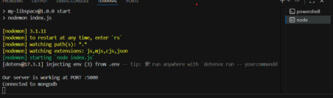
User registration output:
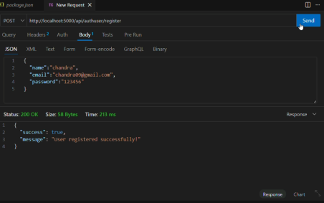User Login output:
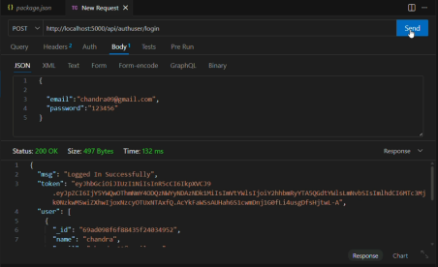Adding book:
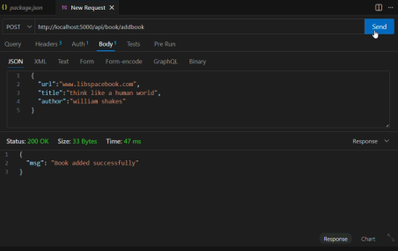Get All books:
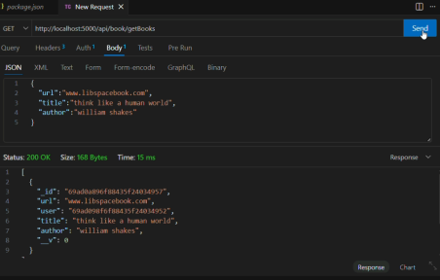Get book by ID:
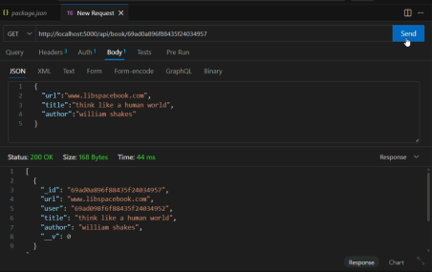Update book:
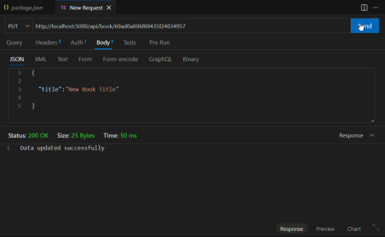Delete book:
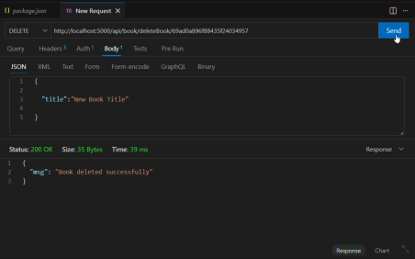User Logout:
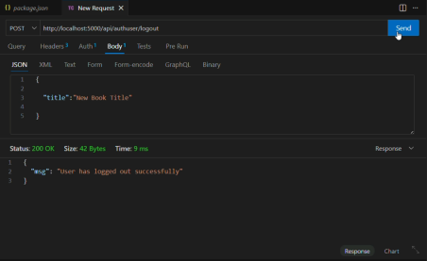10.Demo video Link:
https://drive.google.com/file/d/1XDV8Li1ZC4yPMjgg0Sxbzs22cSy99qp9/view?usp=drive_link

